GRASP – CP
23P-0566 || 23P-0599 || 23F-0662

MOVIE TICKET BOOKING SYSTEM USING GRAPS PRINCIPLES

- Identify appropriate GRASP principles in a design scenario:
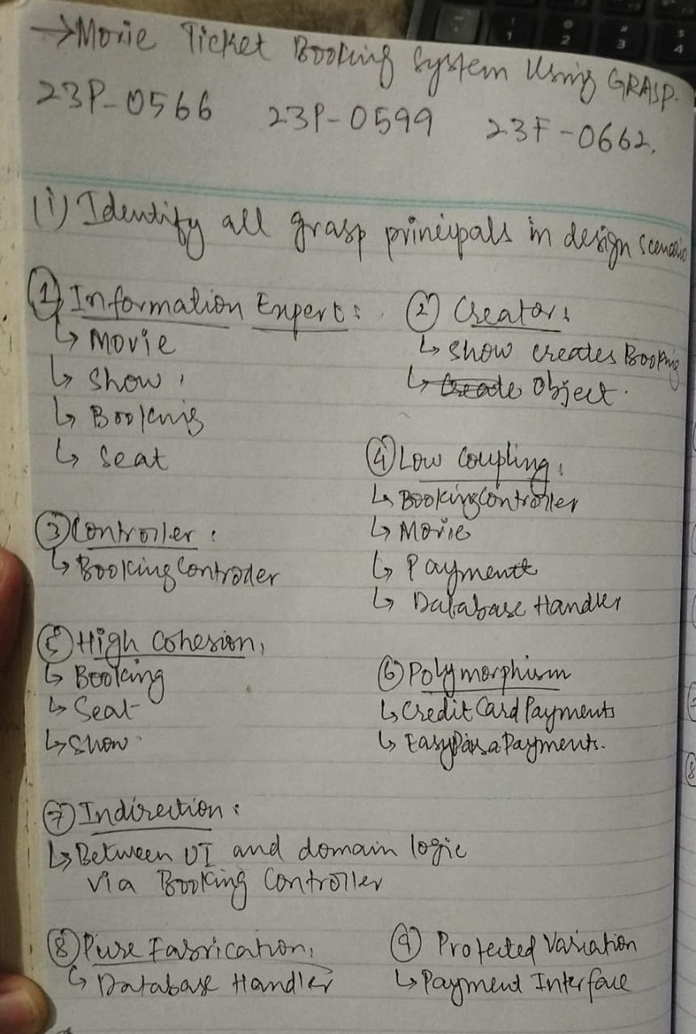’
- Assign class responsibilities effectively based on GRASP patterns.
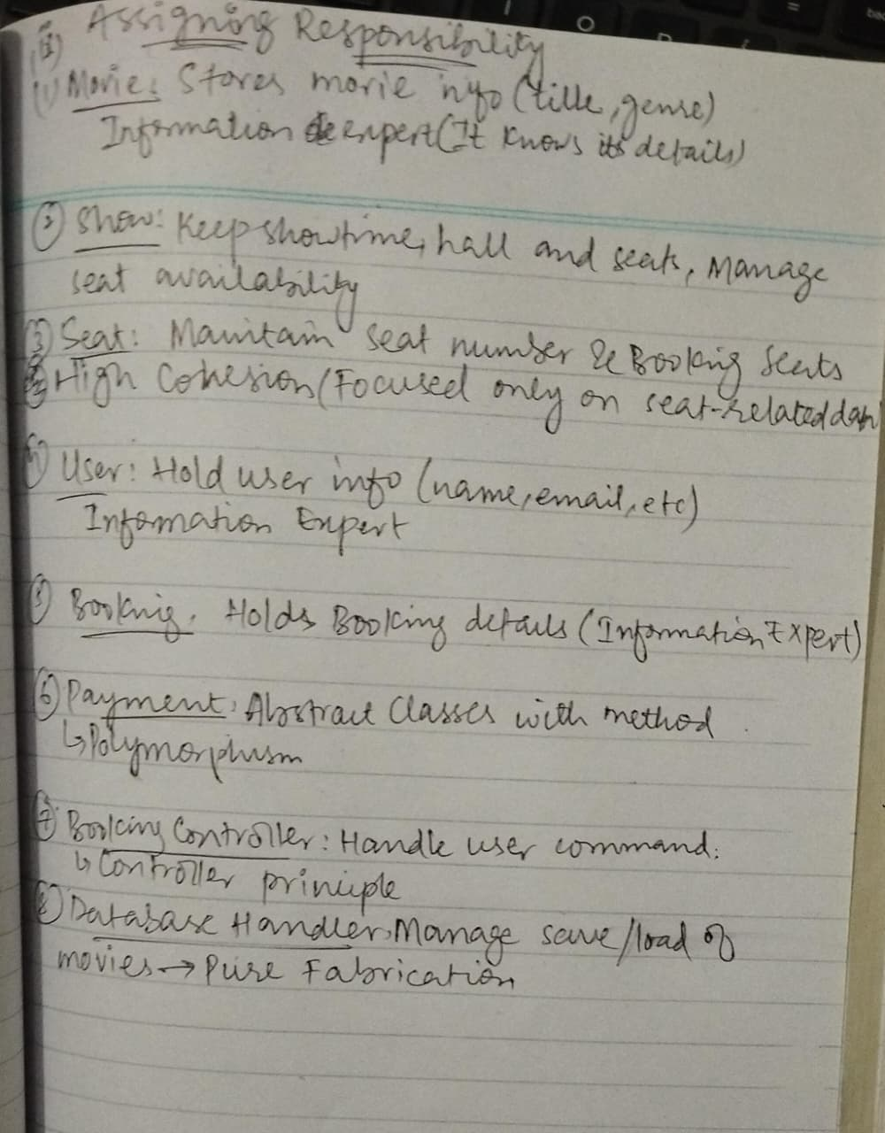

- How GRASP Improved Cohesion and Design Quality
Benefit | Explanation
Improved Cohesion | Each class has a single, focused purpose — e.g., Seat handles only seat status, Booking only booking details. This makes code easier to maintain and understand.
Reduced Coupling | Controller mediates communication, and database logic is separated — changes in one part don’t affect others.
Extensibility | New payment methods or new features (like “Refund”) can be added with minimal impact — thanks to polymorphism and protected variations.
Clear Responsibility Flow | Responsibilities are assigned logically to the classes that have the needed data (Information Expert principle).
Flexibility and Reuse | Components like Payment, Show, and DatabaseHandler can be reused in other systems.

- Identify What the System Needs to Do (Functional Requirements)
1. Search and View Movies
- Browse list of currently available movies.
- View movie details (title, genre, duration, rating).
- Search movies by name, genre, or date.
2. View Showtimes
- View available showtimes for each movie.
- See available cinemas/halls for specific showtime.
3. Select Seats
- Display seating layout for a chosen show.
- Show available/booked seats.
- Allow users to select desired seats.
4. Create Booking
- Create a booking for selected movies, showtime, and seats.
- Link booking with a specific user account.
- Generate a unique booking ID.
5. Process Payment
- Support multiple payment methods (Credit Card, Easypaisa, JazzCash, etc.).
- Verify payment and confirm booking.
- Generate electronic receipts.
6. Generate and Deliver Ticket
- Create an electronic ticket after payment success.
- Send confirmation via email/SMS.
7. Cancel or Modify Booking (Optional)
- Allow users to cancel a booking before showtime.
- Update seat availability and issue refund if applicable.
8. Admin Features (Optional)
- Add new movies and showtimes.
- Manage halls and seating arrangements.
- View all bookings and reports.

- How High Cohesion Is Ensured
Class | Cohesive Responsibility | Explanation
Movie | Stores and manages movie information only. | It doesn’t handle booking or payment — it only provides details like title, genre, and duration.
Show | Manages showtime, cinema hall, and seat availability. | Keeps all show-related logic together. Doesn’t handle payment or user logic.
Seat | Tracks seat number and status (available/booked). | Doesn’t manage shows or bookings — stays focused on seat data.
Booking | Manages booking details (user, show, seats, payment). | Keeps all booking-related behavior in one place.
Payment | Handles payment logic only. | Payment methods are separated by subclasses — cohesive for each type (e.g., CreditCardPayment).
Ticket | Represents a confirmed booking with seat and show info. | Only focuses on ticket details, not on payment or seat availability.
BookingController | Coordinates between user and system classes. | Keeps orchestration logic here instead of spreading across classes.
DatabaseHandler | Manages saving/loading data from storage. | Database logic is separate from business logic, ensuring focus.
NotificationService | Sends confirmations (email/SMS). | Messaging logic separated from booking to maintain cohesion.
- How Low Cohesion Is Ensured
Class | Cohesive Responsibility | Explanation
User → BookingController | User communicates only with the controller, not with every subsystem. | Controller, Indiection
Controller → Booking, Payment, Show | Controller delegates tasks — it doesn’t contain business logic itself. | Low Coupling
Booking → Ticket | Booking creates ticket using information it already has. | Creator
Booking → Payment | Uses a common Payment interface; doesn’t depend on specific payment classes. | Polymorphism + Protected Variations
Show → Seat | Show manages seats as a collection; no need to know booking or payment details. | Information Expert
Booking → DatabaseHandler | Booking doesn’t directly deal with storage; DatabaseHandler handles persistence. | Pure Fabrication
NotificationService → Booking | NotificationService only takes finalized booking info to send messages. | Low Coupling

